CHIRAL APPLICATION NOTE

Sample name: (R)-1-benzhydryl-3-(1-((2-butyl-4-chloro-1-((2’-(1-trityl-1H-tetrazol-5-yl)-[1,1’-biphenyl]-4-yl)methyl)-1H-imidazol-5-yl)methoxy)but-3-en-2-yl)azetidin-3-ol

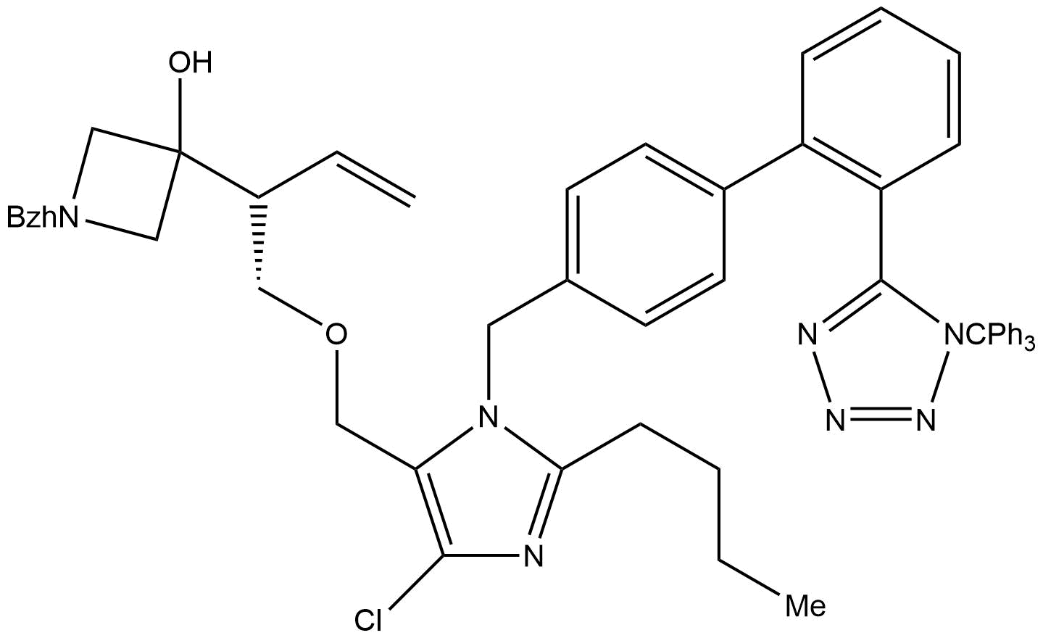
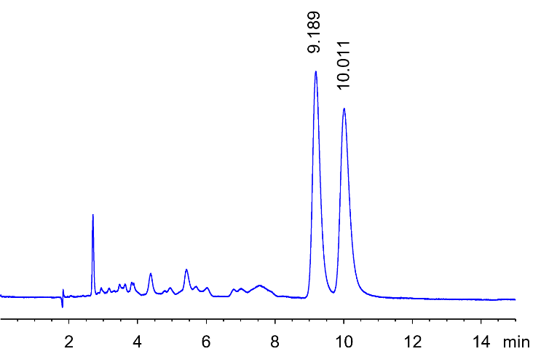
Chromatogram: Structure:

Run Conditions:

Column: NicoShell (15cmx3.0mm, 2.7µm)
Mobile phase: 10/10/80 MeOH/EtOH/Hexane
Flow Rate: 0.3 mL/min
Temperature: Ambient (23 °C)
Injection Volume: 0.3 µL
Detection: UV 237 nm

Retention (min): 9.189/10.011 (Peak1/Peak 2)

Resolution: 1.88

